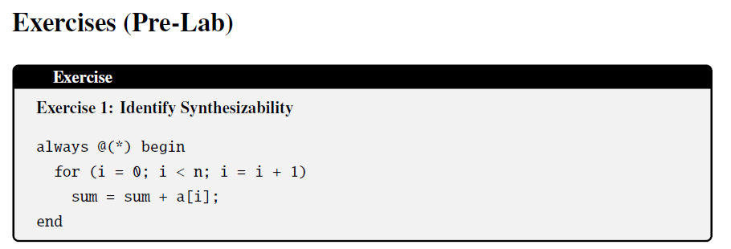
For n = 4, the code creates n parallel adders connected in a chain. It generates hardware in this way:
Sum = a[1] + a[2] + a[3] + a[4]
This code is synthesizable provided that:
- N must be a constant parameter (fixed at compile time)
- The sum needs to be initialized before the loop
- The array indices need to be within bounds

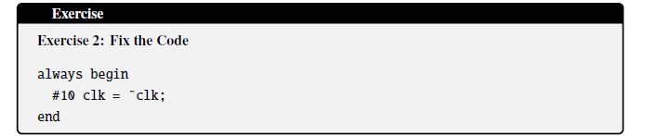
- Always block needs to know when to execute, it should be always @(posedge clk) or always @(*). Without this, the simulator does not know when to trigger.
- FPGAs cannot wait 10 nanoseconds in code. Hardware timing comes from actual circuit paths, not code delays
- We cannot create a clock using regular logic gates
- No reset is written. Without reset, clk will start at 0 or 1 randomly.
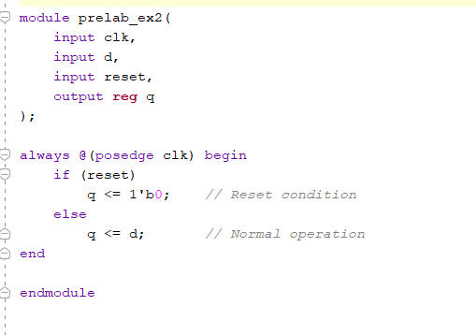
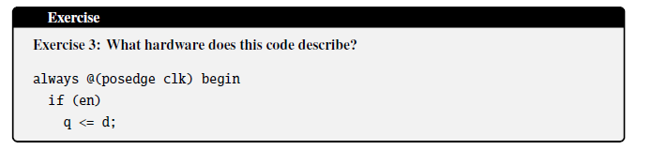
This code describes a D Flip-Flop with Clock Enable
When en is 1: the clk has a rising edge, and q is updated (gets d).
When en is 0: there will be no change, and q keeps its current value.

